|  |  |
| --- | --- |
| **TEAMID** | PNT2022TMID17666 |
| **PROJECTNAME** | IOT BASED SAFETY GADGET FOR CHILD SAFETY  MONITORING AND NOTIFICATION |
| **NAME** | PRIYA |
| **ROLLNO** | 611619205039/319UIT039 |

ASSIGNMENT-1

Create a circuit with piezoalarm,PIRsensor,tmp sensor with below functionalities:

1.Alarm should sound in one manner if temp is above 60 C 2.Alarm should sound with another frequency if motion is detected in PIR sensor

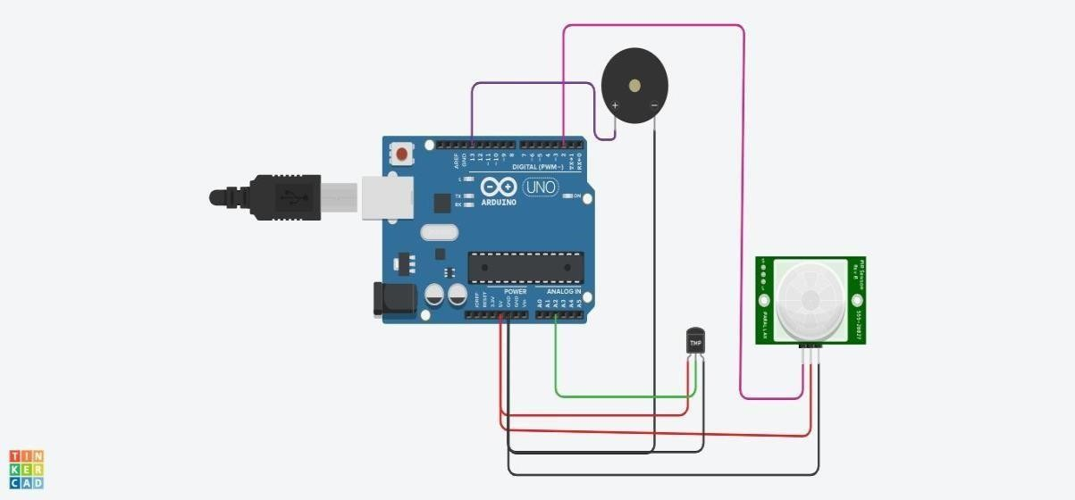

CIRCUIT

// C++ code

//

void setup()

{

Serial.begin(9600); pinMode(2,INPUT); pinMode(13,OUTPUT);

}

void loop()

{

int motion=digitalRead(2);

Serial.print("Position is"); Serial.println(motion); if(motion==1){ tone(13,100);

delay(500);

}

else{ noTone(13);

}

double data=analogRead(A2); double n=data/1024;

double volt=n*5; double off=volt-0.5; int temp=off*100;

Serial.print("Temperature is:"); Serial.println(temp); if(temp>=60){

tone(13,400);

delay(500);

}

else{ noTone(13);

}

}

**OUTPUT:**

